34.90: a) 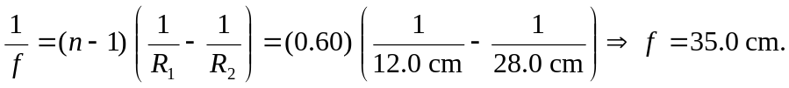 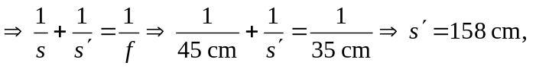and
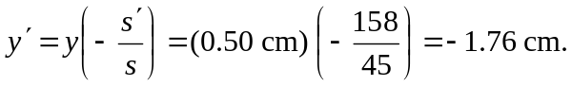
b) Adding a second identical lens 315 cm to the right of the first means that the first lens’s image becomes an object for the second, a distance of 157 cm from that second lens.
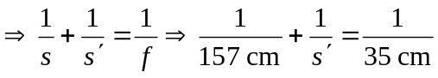
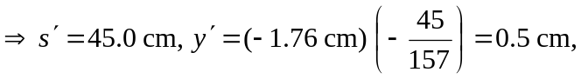
and the image is erect.
c) Putting an identical lens just 45 cm from the first means that the first lens’s image becomes an object for the second, a distance of 113 cm to the right of the second lens.
and the image is inverted.

